Administer Active Directory Domain Services (AZ-1008) Lab Guide

Practice lab Active Directory Administration

Lab Topology
DC01 (Windows Server 2022)
- Active Directory
- DNS
CLIENT01 (Windows 11)
Domain: contoso.local
Objectives
Deploy and manage Domain Controllers
Transfer FSMO roles
Create Sites and Subnets
Manage Users, Groups, and OUs
Configure Group Policy
Configure Fine-Grained Password Policies
Delegate Permissions
Configure Auditing

Create Users
John.Admin
Mary.IT
David.Support

Create Groups
IT_Admins
HelpDesk
HR_Users

Create Organizational Units
HeadOffice
IT
HR
Finance

Group Policy Tasks
Disable control panel
Set password complexity
Map network drives
Configure desktop wallpaper
Security Tasks
Create a Fine-Grained Password Policy
Enable AD Recycle Bin
Delegate password reset rights to HelpDesk
Configure Advanced Auditing

Mock Assessment
- Create a new user.
- Create a group and add the user.
- Create an OU and move the user.
- Create a GPO and link it.
- Transfer a FSMO role.
- Create a Site and Subnet.
- Recover a deleted user from AD Recycle Bin.
- Create a gMSA account.
- Configure a Fine-Grained Password Policy.
- Delegate permissions to another administrator.

H

Step 1: install the window server 2019 and win 10 iso

- Got to this website to download the iso

https://www.microsoft.com/en-us/evalcenter/evaluate-windows-server-2019

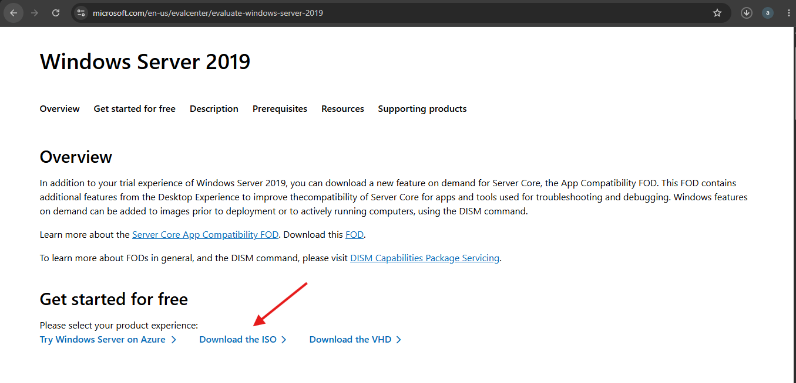

- Click on Download the ISO and fill the form so you can have 180 days trail
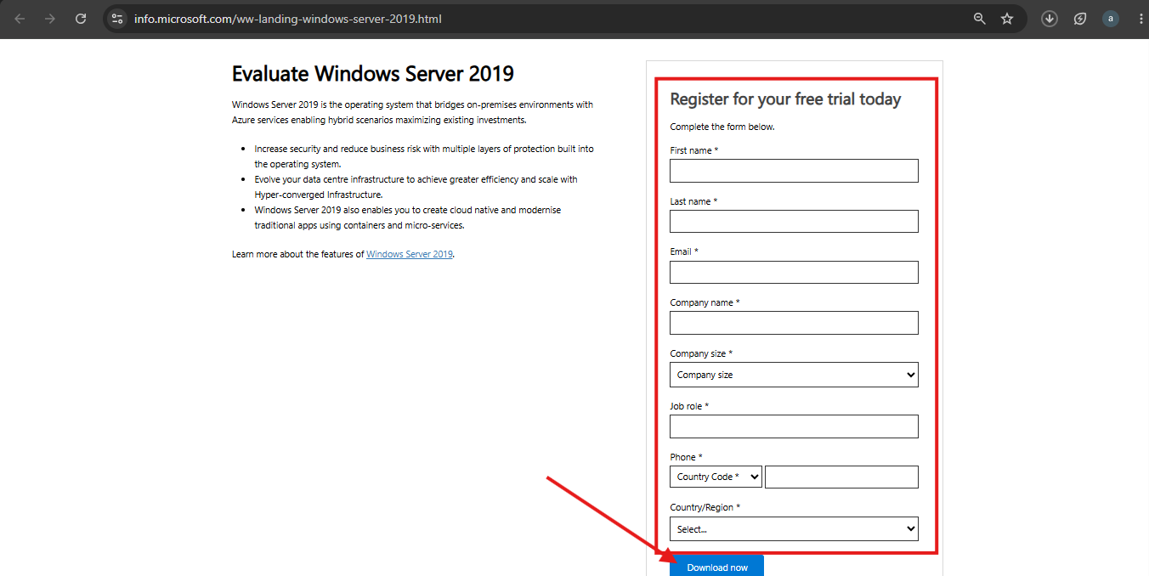

Then click download iso
- Then download the ISO from here
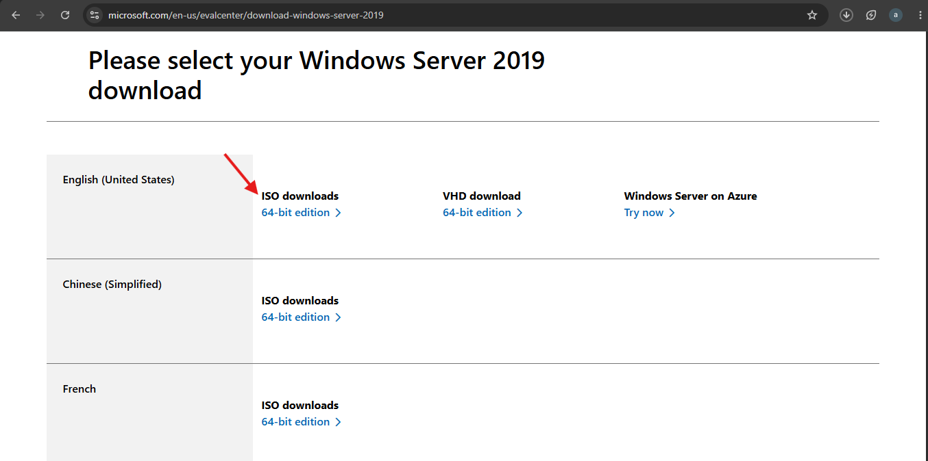

Step 2: set up 1 window 10 and 2 window server 2019 on Hyper-V making 3 vms

- Activate Hyper-v
- Search turn window feature On or Off
- Then a diaglog box appear then select Hyper-v and click okay
- Wait for the applying changes to apply
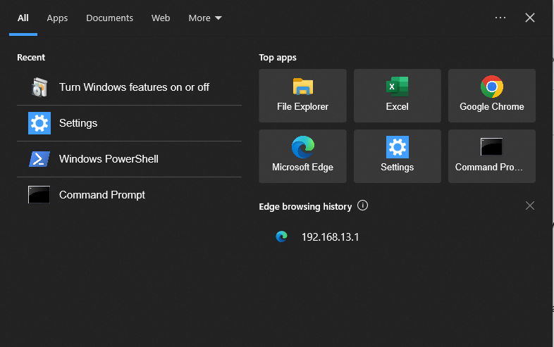
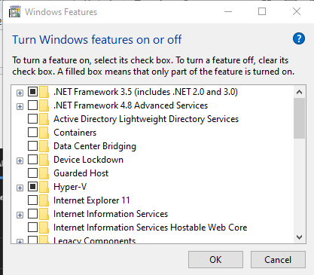
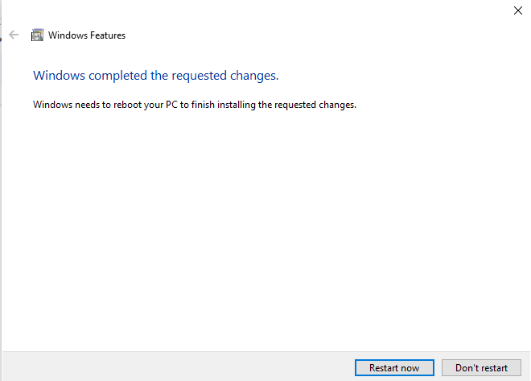

- Search Hyper-v on the window search bar and Open it.

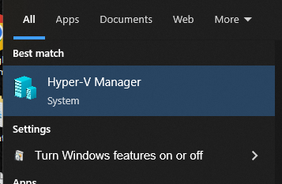

- Click Desktop then Click on New the virtual machine
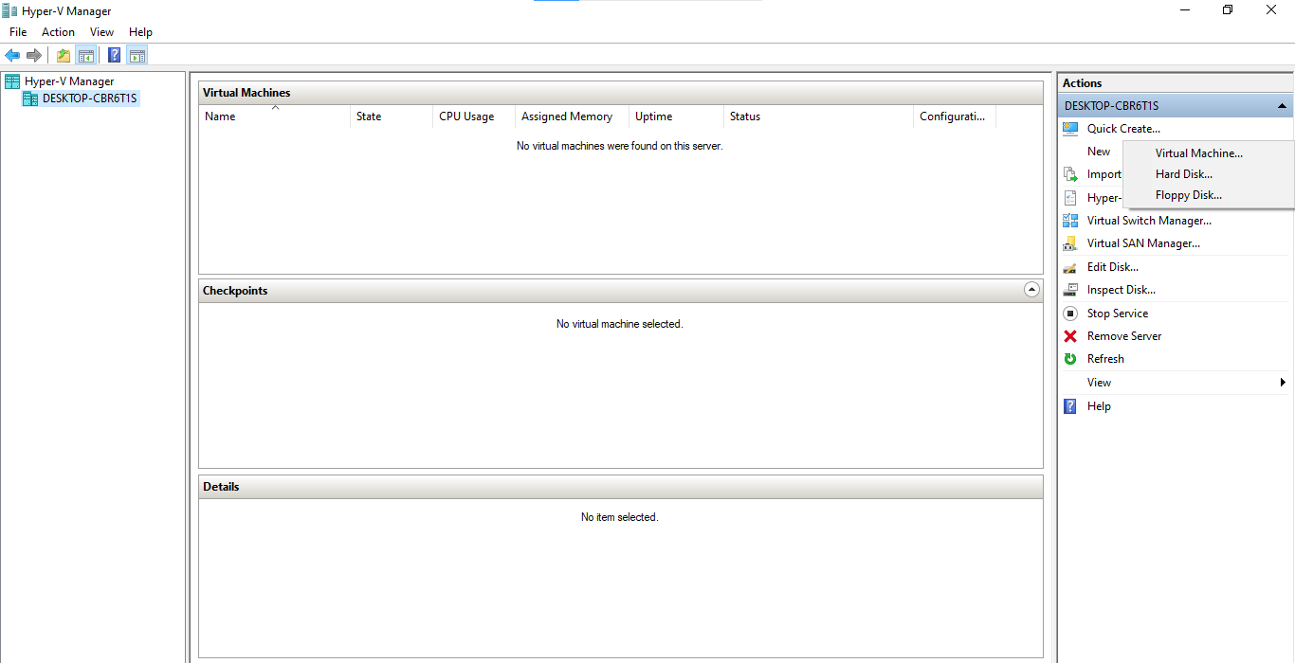

- Set up the necessary information like VM name, ram, storge, selecting iso image ,etc and click finish
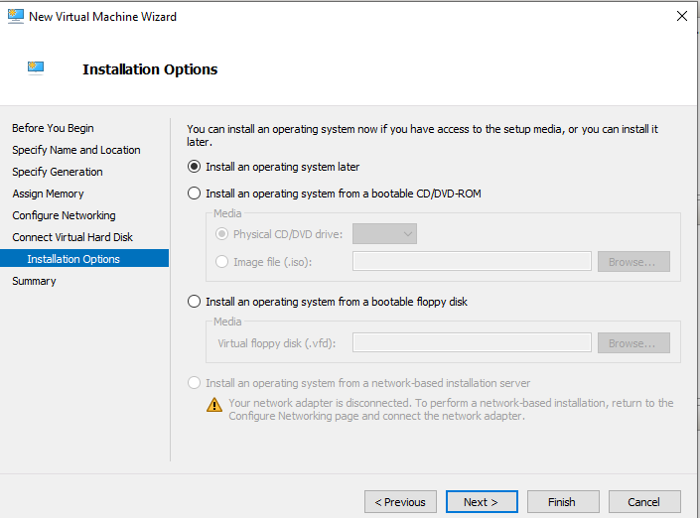
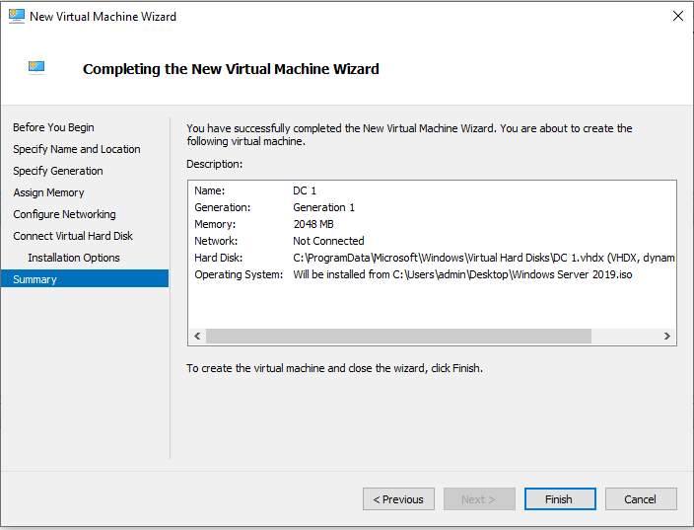

- Now turn on the vm setup so it can install the os by double click on it and click start
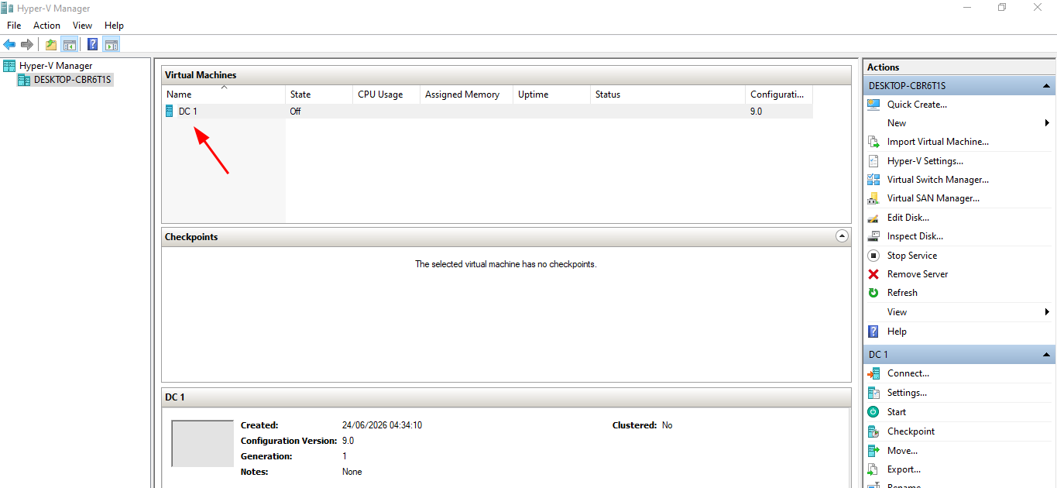
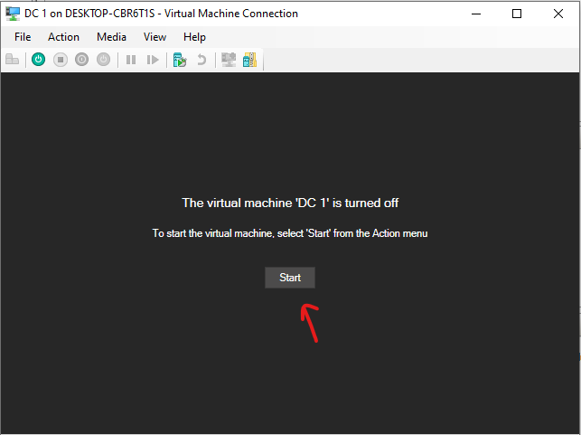

- Then the window server installation will come up but you will select window server 2019 Standard Evaluation desktop experience and follow the wizard
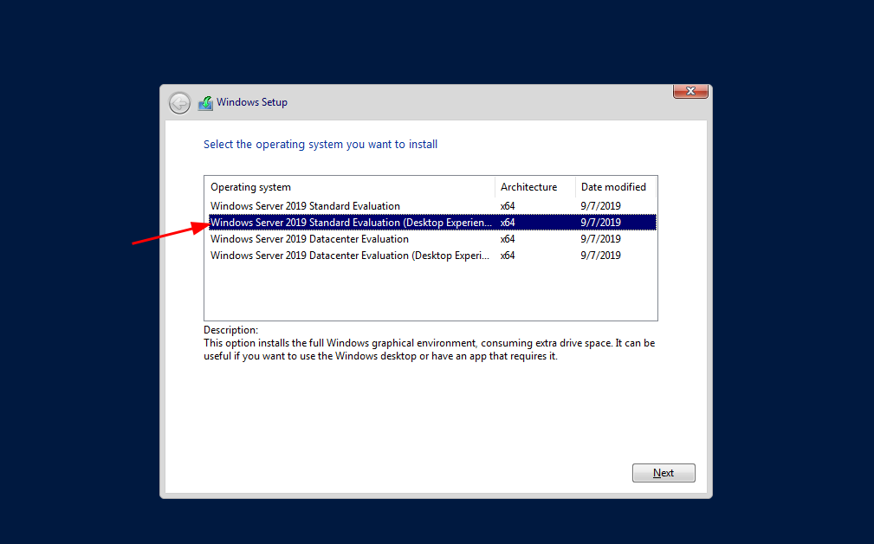

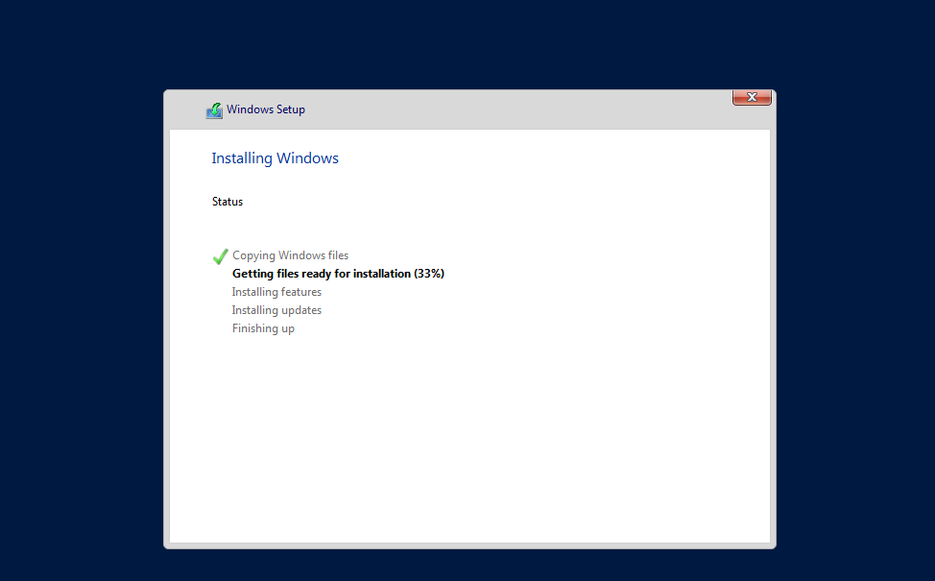

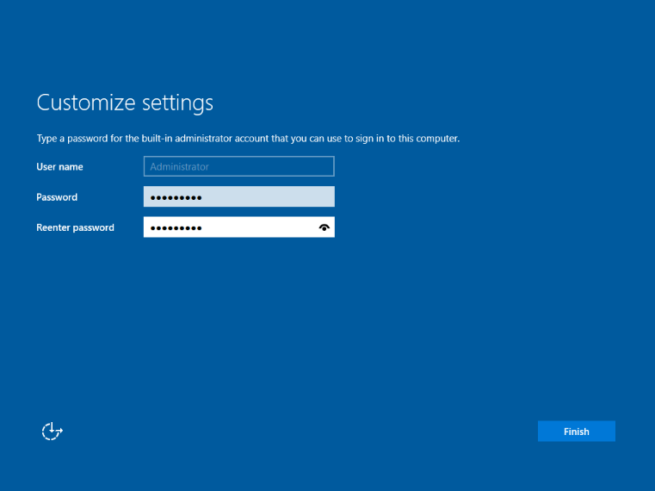

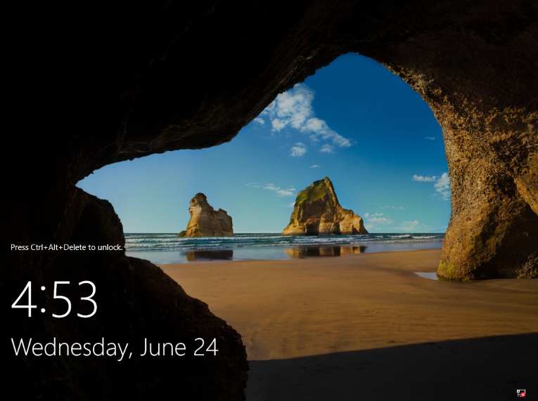

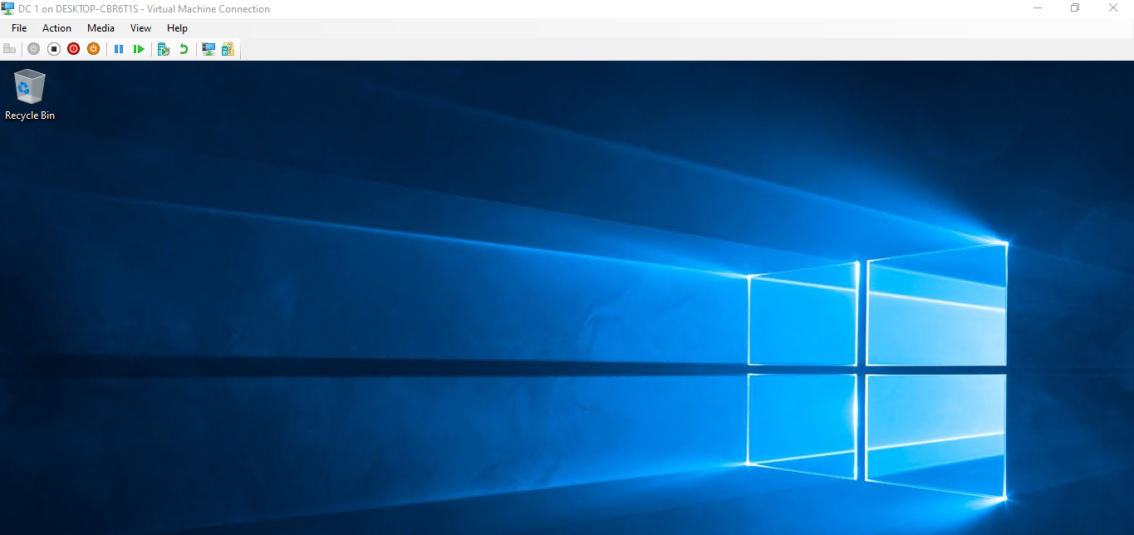

For Vm 2 and windows 10 just do normal installation

Step 1: Create an External Virtual Switch

Objective
Create an external virtual switch in Hyper-V to enable the virtual machines to communicate with the physical network and access external resources.

Actions Performed
- Opened Hyper-V Manager.
- Selected Virtual Switch Manager.
- Choose Create Virtual Switch.
- Selected the Private virtual switch type.
- Clicked Create Virtual Switch.
- Configured the following properties:
  - Name: Private
  - Connection Type: External Network
  - Network Adapter: Wireless (Private)
- Clicked Apply, then OK.
- Waited for Hyper-V to apply the network configuration changes.

Configuration Details
Setting | Value
Virtual Switch Name | Ext
Switch Type | External
Network Adapter | Wireless (Private)

Validation
- Verified that the virtual switch Ext was successfully created.
- Confirmed that the switch appeared in the list of available virtual switches within Hyper-V Manager.

Result
An external virtual switch named Ext was successfully created, allowing virtual machines to communicate with the host network and external devices.

Notes
- An External virtual switch bridges the virtual machines to the physical network.
- Network connectivity may be temporarily interrupted while Hyper-V applies the new virtual switch configuration.

Step 2: Configure the Primary Domain Controller (DC1)

Objective
Prepare the Windows Server by configuring the system time, network settings, and computer name before installing Active Directory Domain Services (AD DS).

Actions Performed

2.1 Verify Date and Time
- Checked the system Date and Time.
- Confirmed that the date, time, and time zone were correctly configured.

2.2 Configure Network Settings
- Verified network connectivity.
- Configured the server with a static IPv4 address.
Network Configuration
Setting | Value
IP Address | 192.168.20.1
DNS Server | 192.168.20.1
Saved the network configuration by selecting OK.
Must Sure it is Connected to the Switch, go to the server manager, right click on DC 1 and click on setting to to switch and pick switch created.

2.3 Rename the Server
- Opened Server Manager.
- Changed the computer name to:
DC1

- Restarted the server to apply the new computer name.

Validation
- Confirmed that the server was reachable using the configured IP address.
- Verified that the computer name was successfully updated to DC1 after the restart.
- Ensured the static IP configuration remained in place after reboot.

Result
The server was successfully prepared for Active Directory installation with:
- Correct date and time configuration.
- Static network configuration.
- The hostname changed to DC1.

Important Notes
- Domain Controllers should always use a static IP address.
- Accurate system time is essential for Active Directory and Kerberos authentication.
- Renaming the server before promoting it to a Domain Controller helps avoid unnecessary changes after deployment.

Technical Note: RAID Overview

Purpose
RAID (Redundant Array of Independent Disks) is a storage technology that combines multiple physical disks to improve performance, fault tolerance, or both.

Common RAID Levels

RAID 0 (Striping)
- Minimum of 2 disks.
- Provides improved read and write performance.
- Does not provide redundancy or fault tolerance.
- Failure of a single disk results in complete data loss.

RAID 1 (Mirroring)
- Minimum of 2 disks.
- Stores identical copies of data on each disk.
- Provides high availability and simple recovery if one disk fails.
- Storage capacity is reduced by half because data is duplicated.

RAID 5 (Striping with Distributed Parity)
- Minimum of 3 disks.
- Balances storage efficiency, performance, and fault tolerance.
- Can tolerate the failure of one disk without data loss.
- If two disks fail simultaneously, data cannot be recovered.

RAID 6 (Striping with Double Parity)
- Minimum of 4 disks.
- Can tolerate the failure of two disks simultaneously.
- Offers greater fault tolerance than RAID 5.
- Requires additional storage capacity and processing resources for parity calculations, resulting in slightly reduced write performance.

Key Learning Points
- RAID improves storage reliability and, depending on the level, can also improve performance.
- RAID is not a replacement for backups; it provides fault tolerance, not protection against accidental deletion or corruption.
- RAID 0 focuses on performance, while RAID 1, RAID 5, and RAID 6 prioritize data protection with different levels of redundancy.
- RAID 5 is a common balance between performance and fault tolerance, whereas RAID 6 is preferred in environments where higher disk failure tolerance is required.

Adding the AD services roles on the DC 1 server from Server manager

- On the Window Desktop launch - Server Manager -
- Click on Tool - No Ad install
- Click on local server and change the computer name to DC 1 and restart
- Proceed and Click on Add Role and Feature - under server roles select Active Directory Domain service and DNS Server add features keep click next and finish the installation you will see the AD component
- The next Step is to Promote the server
- Under Deployment Configuration-Select Add as a new Forest
- And then Root Domain name: abc.net
- Set your DSRM password - is used for safe mode when the server is bad
- Domain name: abc
- Install and it will reboot

How to login Now
Username: abc\administrator
Password; login with your default password

Configuring DC 2

Prepare the Windows Server by configuring the system time, network settings, and computer name before installing Active Directory Domain Services (AD DS).

Actions Performed

2.1 Verify Date and Time
- Checked the system Date and Time.
- Confirmed that the date, time, and time zone were correctly configured.

2.2 Configure Network Settings
- Verified network connectivity.
- Configured the server with a static IPv4 address.
Network Configuration
Setting | Value
IP Address | 192.168.20.2
DNS Server | 192.168.20.1
- Saved the network configuration by selecting OK.
Must Sure it is Connected to the Switch

2.3 Rename the Server
- Opened Server Manager.
- Changed the computer name to:
DC2

- Restarted the server to apply the new computer name.

Adding the AD services roles on the DC 2 additional DC server from Server manager

- On the Window Desktop launch - Server Manager -
- Click on Tool - No Ad install
- Click on local server and change the computer name to DC 2 and restart
- Proceed and Click on Add Role and Feature - under server roles select Active Directory Domain service and add features keep click next and finish the installation you will see the AD component
- The next Step is to Promote the server
  - Under Deployment Configuration-Select Add a new domain an existing domain

  - And then Root Domain name: abc.net
  - You have to login the DC 2 so that it will reference it
Username: abc\administrator
Default password then it will reference it
  - Set your DSRM password
  - In additional option - replicate from - any domain controller
  - Install it

After confirming the Ad server is running then the thing to do is

Configure DNS reversed lookup on DC 1

- Select DNS under server manager tool
- Right click on Reversed Lookup zone and click New zone
- Under Active directory zone replication scope select To all DNS servers running on domain controller in this domain abc.net
- Network id = 192.168.20 then finish

Login To DC1
Username: abc\administrator
Password; login with your default password

Creating Ou (Organizational Unit)
- Go to tool under server manager
- Click on AD user and Computer
- Right Click on the Domain - abc.net
- Right click and select new - select Organizational Unit then name it Headoffice
- Right click and select new - select Organizational Unit then name it IT
- Right click and select new - select Organizational Unit then name it HR
- Right click and select new - select Organizational Unit then name it Finance

Creating User
- Go to tool under server manager
- Click on AD user and Computer
- We have 4 Ou (Organization Unit)
- Under IT right click, click on new - select user
- Name it John Admin
- Username: John
- Set your Default Password
- Then click on okay
Since we are creating other user too and it is the under the same unit we can right click and copy properties of John and duplicate it to other like creating user for Mary IT, david Support

Creating Group
- Right on abc.net and select group under new
- First Group - IT_admin
- Second Group - HelpDesk
- ThirdGroup - HR

Adding the users created to their specific groups
- Double link on the user name John
- Go to member of and click on Add
- Enter the group name and check names then add it
- Apply and okay

Same process for David Support

- Double link on the user name david
- Go to member of and click on Add
- Enter the group name ( HelpDesk) and check names then add it
- Apply and okay

Applying On DC 1
N.B: You will create group policy first, configure it and then apply it

Policy 1: Disable Control Panel

Steps
- Select tool from Server Manager and choose Group Policy Management
- Check under Abc.net, select Group Policy Objects
- Right Click on it, create new and Name it Disable Control Panel
- Now Dropdown under Group policy Object and Pick Disable Control Panel right click on it and then edit it
- Under Disable Control Panel go to user- configuration and select Administrative Template under policies
- And select Control Panel
- Double click on Prohibit access to Control Panel and Pc settings and configure it (Enable it) and add your comment
- To bind this GPO right click on abc.net and select link to and existing GPO then select Disable Control Panel and click on it

Policy 2: Password Policy SOP

Steps
- Select tool from Server Manager and choose Group Policy Management
- Check under Abc.net, select Group Policy Objects
- Right Click on it, create new and Name it Password Policy SOP
- Now Dropdown under Group policy Object and Pick Password Policy right click on it and then edit it
- Under Password Policy go to Computer configuration and select Administrative - Policies - window Setting - Security Setting
- Then Click on Account Policies
- Under Account Policies, then Double click on password Policy, minimum password length properties
- Enable password complexity requirement
- Then configure it (enable it)
- To bind this GPO right click on abc.net and select link to and existing GPO then select Password Policy SOP and click on it

Policy 3: Map Network Drive
N.B: You must Create a Shared Folder on your Desktop Computer
Folder name: Shared
Right Click on the folder and select the properties
Go to shared and go to advanced setting
Tick share this folder then all access for anyone apply

Then go to share, click on edit, select object name everyone and check name, then add it
Then copy the the shared folder url

The Copy Share Folder url will be needed in the Group Policy

Steps
- Select tool from Server Manager and choose Group Policy Management
- Check under Abc.net, select Group Policy Objects
- Right Click on it, create new and Name it Map Network Drive
- Now Dropdown under Group policy Object and Pick Map network Drive right click on it and then edit it
- Under Map Network Drive go to user- configuration and select Preference - Window settings
- Then select Drive Map, right click and select new
- Put the share link in the Location
- Label as: Lab stuff
- Drive letter - select Z
- Done

Policy 4: Wallpaper
Note: you must have the wallpaper in the folder created
- Select tool from Server Manager and choose Group Policy Management
- Check under Abc.net, select Group Policy Objects
- Right Click on it, create new and Name it Desktop Wallpaper
- Now Dropdown under Group policy Object and Pick Map network Drive right click on it and then edit it
- Go to user config - admin temp - Desktop - Desktop Wallpaper
- Click on it and configure it (enable)
- Paste the the location url
- Set the wallpaper style to fill then click on apply then okay
- To bind this GPO right click on abc.net and select link to and existing GPO then select Desktop wallpaper and click on it

Policy 5: Welcome Banner

Open Group Policy Management
Create a New GPO
- Name: Welcome Banner
Edit the GPO
- Right-click Welcome Banner
- Click Edit
Navigate to Security Options
Computer Configuration
→ Policies
→ Windows Settings
→ Security Settings
→ Local Policies
→ Security Options
5. Configure Message Title
- Double-click:
Interactive logon: Message title for users attempting to log on
- Enable the policy
- Enter title:
Welcome to Fidson
- Click OK
6. Configure Message Text
- Double-click:
Interactive logon: Message text for users attempting to log on
- Enable the policy
- Enter message:
Welcome to Fidson Healthcare Plc.

Fidson Healthcare Plc is one of Nigeria's
leading pharmaceutical companies, committed
to providing quality healthcare products
and services across Nigeria.

This system is for authorized users only.
All activities on this system are monitored.

By logging in, you agree to comply with
Fidson's IT policies and guidelines.
- Click OK
7. Apply the Policy on CLIENT01
- Open Command Prompt on CLIENT01
- Run:
gpupdate /force
8. Verify
- Log out of CLIENT01 completely
- The welcome banner appears before the login screen
- Click OK to proceed to login

To enforce all the policy
- Go to window
- Search cmd
- Then run this command gpupdate /force
Then restart the DC1 and login back
Username: Administrator
Password: Default Password7

Fine Grained Password Policy
- Open Active Directory Administrative Centre
- Under the domain dropdown and loom for system
- Under system look for password setting container
- Right click and create a new one
- Name it strictpolicy
- Precedence: 12
- Enfore Account out policy after 3 trial
- Under Directly applied assign to IT_admin
- Then click on Okay

Enable AD Recycle bin
- Open Active Directory Administrative Centre
- On the Domain, Right Click on it
- Pick enable recycle bin
- Enable it

Delegate Permission
- Go to tool under it
- Select AD users and Computer
- Select IT OU and Right click on it
- Select Delegate Control
- Add Helpdesk
- The choose the Permission/tasks you want to delegate to the group like Reset User Passwords
- The click on finished

Delegate Permission
- Go to tool under it
- Select Group Policy Management
- Go to Domain - select Group policy Object - select Default Domain Controller
- Right click on it and edit
- Go to computer config - Policies - Windows settings - Security Settings - Advanced Audit Policy - Audit Policy
- The choose Logon/off event enable it both success and failure
- And for the Account Management too do the same when it is Sucess and Failure
- The apply

Create Site and Subnet
- Go to tool under it
- Select AD site and Services
- Click on Site
- Right Click On site and name it Abuja
- Right Click on Subsnet to create a new Subnet and assign the Ip address: 192.168.20.0/24
- Then select Abuja then click on Okay.
- Then under Default First-site Name - server - you will see DC1 and DC2
- The move DC2 to the site created called Abuja

Recover Deleted User
- Deleted a tested user
- Open ADAC
- Open - deleted Objects
- Restore User

Configuring Client
Steps
- Update the time Zone and Date
- Change the computer name (Client 01 ) and reboot it
- Configure the network and assign an IP address = 192.168.20.3
DNS 192.168.20.1
Alternative DNS 192.168.20.2
- Now join the client to abc.net domain then it will restart

Login using Administrator

After that as
Username: .\client
Password: Default Password

To login to Other User created On Server DC 1
Steps
- To start and search for Computer Management
- Click on it, then Select local user and Groups
- Then select groups
- Look for remote Desktop User Properties then add the user created
Then you can now login and check the user maybe it will works

E,g logging in to John Admin
Username: John
Password: Default password

